Objective:

To walk through the process of defining software architecture of a system using UML diagrams

1. Recommend the software architecture pattern used for this system.

Rapid Application Development Style

1. Design the use case diagram for the system. Since it’s all about viewing sales reports, login into the system is must.

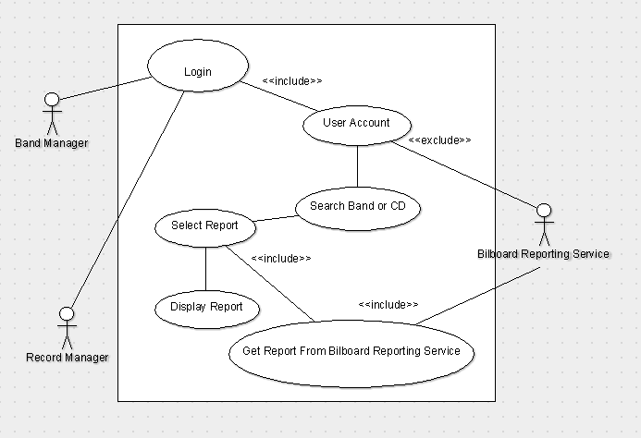

1. Identify the classes and sketch the class diagram using multiplicities. Also define the common attributes and the functions required to define the system
2. Design a sequence diagram that allows the records manager to generate the report for a particular CD for the specific week.

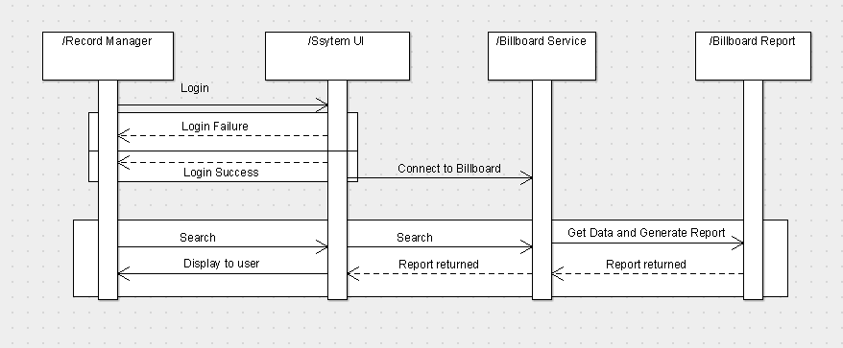

1. Convert this sequence diagram to the communication diagram.
2. Is there any state chart diagram associated with this system? Draw if any
3. Design the activity diagram for generating the report of sales for specific CD by the records manager